Title of the Paper (Use Heading 1 style)
AuthorA SurnameA*, AuthorB SurnameB, AuthorC Surname C, and AuthorD SurnameD (Use Authors style)

Abstract: (Use Heading 2 style)
Text of the abstract not more than 250 words.
Keywords: Keyword one, Keyword two, Keyword three, Keyword, Keyword five (use Keywords style)
Nomenclature
BAC : Boeing Airplane Company (Use Nomencalture Body Style)
LCC : Lockheed California Company
IATA : International Air Transport Association
ACI : Airport Council International

1. Introduction, Use Heading 2 Style
Please use Normal style form the “Styles” for all general text. (Tip, press Alt+Ctrl+Shift+S for Windows version of Office 365 users).
This is the two authors citation in the text. (Momirlan and Veziroglu, 2005). This is more than two author citation in the text (Cecere et al, 2014). This is only one outhor citation in the text (Cecere, 2014). This is two separate citations in the text (Cecere, 2014; Momirlan and Veziroglu, 2005). This is the same authors two citations in the text (Cecere, 2015a 2015b).
This is the two authors citation in the text. (Momirlan and Veziroglu, 2005). This is more than two author citation in the text (Cecere et al, 2014). This is only one outhor citation in the text (Cecere, 2014). This is two separate citations in the text (Cecere, 2014; Momirlan and Veziroglu, 2005). This is the same authors two citations in the text (Cecere, 2015a 2015b). This is the two authors citation in the text. (Momirlan and Veziroglu, 2005). This is more than two author citation in the text (Cecere et al, 2014). This is only one outhor citation in the text (Cecere, 2014). This is two separate citations in the text (Cecere, 2014; Momirlan and Veziroglu, 2005). This is the same authors two citations in the text (Cecere, 2015a 2015b).
This is how to refer a figure Fig.1.
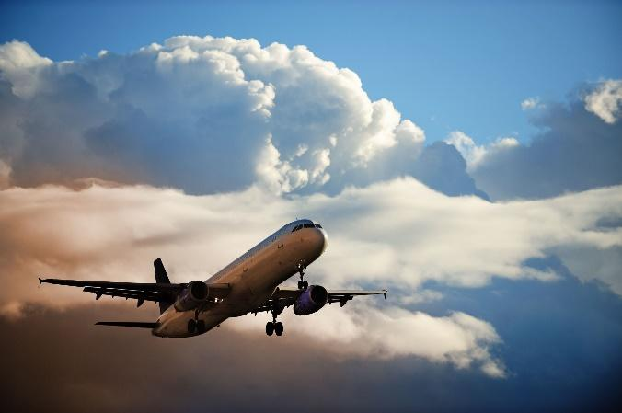
Fig.1. You must get permission from the original 3rd party images, (Van Zon, 2008) use Figure style.
!!!Note that signed copyright permission is mandatory if you used 3rd party material like any published excerpts of copyrighted works (including websites) such as illustrations, tables, animations, or text quotations are included in the mentioned paper!!!

2. Another First Level Paragraph Use Heading 2 Style
Dummy paragraph.Dummy paragraph.

2.1. This is Second Level Paragraph Use Heading 3 Style
Dummy paragraph.Dummy paragraph.
This is how to refer a table Table 1
Table 1: Caption of table, Table style from the Styles Menu (Korycinski, 1978)
Air terminal | Peak output |  | H2 Liquefiers
 | ton/  day | ton/  day | Size ton/day | ton/  day
San Francisco | 846 | 768 | 250 | 227
O'Hare | 800 | 726 | 268 | 243
Please use Table Text style for the texts in the table

2.2. Hydrogen in Air Transportation of A310 Defined Please use Heading 3 Style
Dummy paragraph.
Dummy paragraph should be bigger graphics, pictures, illustrations Fig. 2
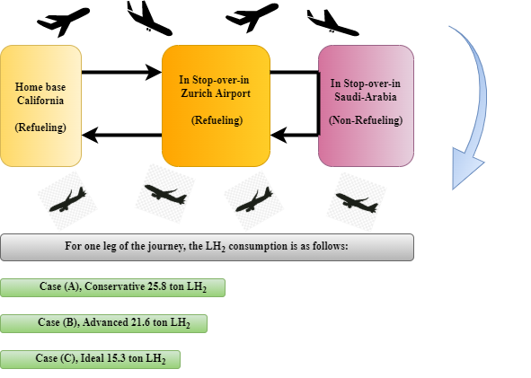
Fig.2. Please use Figure Style for styling a figure caption (Alder, 1987) (Figure Style)
Dummy Paragraph is to show an equation Eq. 1. Please use Equation Style and use Tab keys before and after the equation to format the line. All equations must be written in equation editor. Please do not paste figures instead of equation.
$E=mc2$ (1)

3. Another 2nd Level Heading Please use Heading 2 Style
Dummy text
Dummy text

4. Conclusion in Heading 2 Style
Dummy text
Please use List Paragraph style from the Styles menu to format bulleted items.
- 1st conclusion
- 2nd conclusion
Dummy text
Dummy text, please use References Style to format references section in regards with the instructions of Springer’s key styling guide, basic referencing system as Harvard Cite Them Right CBE Version.

References in Heading 2 Style,
References should be cited in the text and formatted as Harvard Cite Them Right, Council of Biology Editors (CBE), please see the referencing styling guidelines.
ACI (2008) Integration of Hydrogen Aircraft into the air Transport System: An Airport Operations and Infrastructure Review. ACI-ATI Report. aci.aero/publications/new-releases
Airbus (2002) Final Technical Report of Cryoplane Liquid Hydrogen Fuelled Aircraft-System Analysis. Airbus Deutschland GmbH. https://www.fzt.haw-hamburg.de/pers/Scholz/dglr/hh/text_2004_02_26_Cryoplane.pdf
Alder, HP (1987) Hydrogen In Air Transportation. Feasibility Study for Zurich Airport. International Journal of Hydrogen Energy 12(8):571-585. https://doi.org/10.1016/0360-3199(87)90016-4
Baroutaji A, Wilberforce T, Ramadan M, Olabi AG (2019) Comprehensive investigation on hydrogen and fuel cell technology in the aviation and aerospace sectors. Renewable and Sustainable Energy Reviews 106:31–40. https://doi.org/10.1016/j.rser.2019.02.022
Cecere D, Giacomazzi E, Ingenito A (2014) A review on hydrogen industrial aerospace applications. International Journal of Hydrogen Energy. 39(20):10731-10747. https://doi.org/10.1016/j.ijhydene.2014.04.126
Clean Sky 2 (2020) Hydrogen-powered aviation, A fct basd study of hydroge technology, economics, and climate impact by 2050. https://doi.org/10.2843/766989
Korycinski PF (1978) Air Terminals and Liquid Hydrogen Commercial Air Transports, Int. J. Hydrogen Energy 3(2):231-250. https://doi.org/10.1016/0360-3199(78)90021-6
Nout van Zon, () Liquid Hydrogen Powered Commercial Aircraft: Analysis of the technical feasibility of sustainable liquid hydrogen powered commercial aircraft in 2040 p.16. http://www.noutvanzon.nl/files/documents/spaceforinnovation.pdf
Pohl HW, Malychevc V (1997) Hydrogen In Future Civil Aviation, Int. J. Hydrogen Energy 22(10-11):1061-1069. https://doi.org/10.1016/S0360-3199(95)00140-9
Schmidtchen U, Behrend E, Pohl HW, Rostek N (1997) Hydrogen Aircraft and Airport Safety, Renewable and Sustainable Energy Reviews 1(4):239-269. https://doi.org/10.1016/S1364-0321(97)00007-5
Troeltsch F, Engelmann M, Peter F, Kaiser J et al. (2020) Hydrogen powered long haul aircraft with minimized climate impact, in: AIAA Aviation 2020 Forum. American Institute of Aeronautics and Astronautics Inc, AIAA, p. 14. https://doi.org/10.2514/6.2020-2660

